FLExTools Help
Version 1.2
August 2016
For FieldWorks 7 and 8

Introduction
FLExTools is a framework for running custom Python scripts on a FieldWorks Language Explorer database. FLExTools provides core functions for creating small Python scripts (a Module) to do the processing work, and a user interface to make it easy to run the Modules individually or as a set. A set of Modules is called a Collection.
This guide explains how to use the FLExTools application. Further help on programming custom FLExTools Modules can be found on the Help menu:
- Programming Help
- API Help

Choosing a Database
When you run FlexTools.vbs for the first time there is no FieldWorks database selected. For this tutorial use the menu FLExTools | Choose Database or click the Database button on the toolbar. In the Choose Database dialog double-click on Sena 3’.
Notice the status bar at the bottom showing the current database name.

Viewing Module Information
The main window shows two reporting Modules that are included with this installation. You can get more information on what these Modules do by selecting them and clicking the Module Info toolbar button.
(Note, these Modules are configured in the Examples Collection. The status bar at the bottom shows the current Collection name. See the Collections section later for more information about managing Collections.)

Running Modules
Having chosen the Sena 3 database run the Reports.Text Statistics Module. There are four ways to run a Module:
- double-click the Module;
- select the Module and click the Run button in the toolbar;
- select the Module and use the Run command in the Run menu;
- select the Module and use the Ctrl-R shortcut key.
The results appear in the report panel like this:
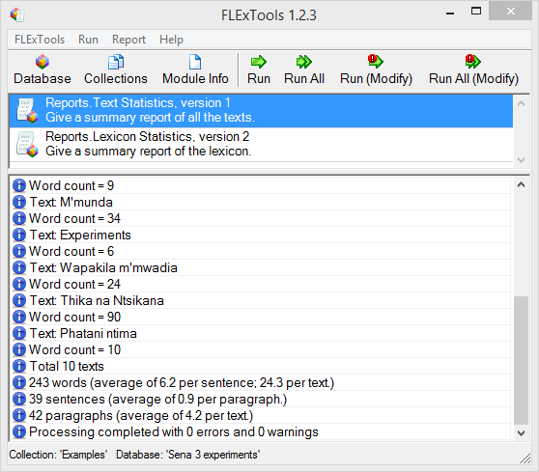
To run all of the modules in the list use the Run All toolbar or menu options.

Report Window
The report panel can show three types of message with the following icons:
Information
Warning
Error
Move the mouse over an entry to see more information in a tool tip. For example, a programming error might look like this:
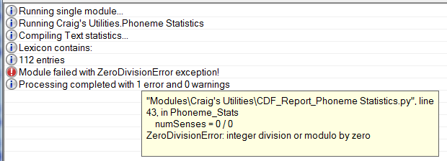
Some messages in the report window contain links to the relevant entry or place within FieldWorks. If this is the case a tool tip will appear when you hover over the message, and double-clicking that line will open FieldWorks at the right place.
Under the Report menu are options to clear the report window and to copy the contents to the clipboard:
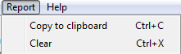

Modifying the Database
For some situations you will want a FLExTools module to make changes to the FieldWorks database. This might be to make automated fixes to data, to insert notes in a lexical entry about an issue that needs to be addressed, or some other specific need.
Be very careful when making changes to the database via FLExTools or any Python script. Backup your database before attempting any changes and check the results carefully.
In FLExTools, any module that can change the database shows this in the main list and in the Module Info dialog. As a safeguard for your data, FLExTools will not make changes to the database unless you are holding down the Shift key when you invoke the Run or Run All commands, or if you click the Run (Modify) or Run All (Modify) toolbar buttons. This allows you to do a “dry run” of a Module to check that it is doing what you expect. Then you can run it again with Shift down to actually make the changes. (See the FLExTools Programming help file for important information on implementing this behaviour in your own Modules.)

Collections
FLExTools Modules are organised into Collections. A Collection is a set of Modules that you want to group together. The current Collection name is shown in the status bar. For a fresh installation it will say “Examples.”
To create new Collections or edit existing ones, open the Collections Manager either with the Collections toolbar button, with Ctrl-L, or via the FLExTools | Collections menu. The Collections Manager looks like this:
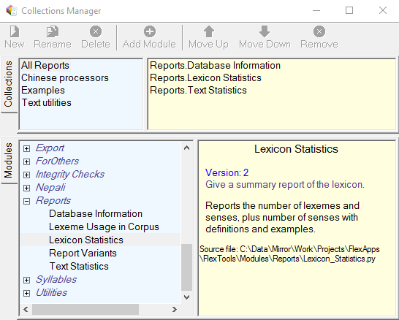
- The top panel shows all the Collections, with the right side showing the Modules that are in the selected Collection.
- The bottom panel shows all the Modules that are installed, with information about the selected Module on the right.
- The toolbar buttons are enabled and disabled according to where the input focus is and the functions available.
To learn how to use the Collections Manager follow the steps below to create a new Collection called “Quality checks.” This will contain Modules that you want to run on a regular basis to check certain aspects of consistency or correctness in your database.
  - Click in the top-left area—the Collections list—and click the New button. Type in “Quality checks” for the name.
  - Choose the Modules you want to be in this Collection from the bottom panel: select the Check Punctuation Module in the Examples group and click the Add Module button, or double-click the Module name.
  - Add other Modules to the Collection as required. In the list in the top-right panel use the Move Up and Move Down buttons to change the order. You can also use the Delete button to remove a Module from the Collection. Note that this does not actually delete the Module itself.
  - Finally, double-click the Collection name to select this as the current Collection and return to the main screen.
You will now see the Check Punctuation Module shown in the top list, and the Collection name “Quality checks” in the status bar. Click Run All to run all of the Modules in this Collection on the current database.

Installing Modules
In the FLExTools installation folder there is a folder called ‘FLExTools\Modules.’ Within this folder you can create a 1-level hierarchy of sub-folders for grouping your Modules into logical categories. In the Collections Manager you will see that the Modules are grouped according to the directory structure within the ‘Modules’ directory. For example, ‘Examples’ and ‘Reports’ in the screen-snap above correlate to folders in the Modules directory.
Copy your Modules (Python scripts) into the Modules folder or any sub-folder. See how to write a Module in FLExTools Programming.pdf (Help | Programming Help.)

Final Notes
- Remember to backup the FieldWorks database before running any Modules that modify the database.
- The database needs to be closed in FieldWorks in order to run FLExTools Modules.

